**University of Portsmouth**

**Computer Games Technology**

**CT5PRGAP**

**UP784120**

**PRGAP - Product Development Document**

*This documentation covers each phase from the requirements of the product through to the design and testing of the system.*

*Product Name*

*Author Name*

*Author Details*

|  |  |  |
| --- | --- | --- |
| Version | Date | Comments |
|  |  |  |
|  |  |  |
|  |  |  |
|  |  |  |
|  |  |  |

# Contents

**Contents 2**

**1.** **Introduction 4**

1.1. Purpose 4

1.2. Scope 4

1.3. Definitions, acronyms and abbreviations 4

1.4. References 4

**2.** **System Requirements Specification 5**

2.1. General Description 5

2.1.1. Product perspective 5

2.1.2. Product functions 5

2.1.3. User characteristics 5

2.1.4. General constraints 5

2.1.5. Assumptions & dependencies 6

2.2. Specific Requirements 6

2.2.1. Hardware Requirements 6

2.2.2. Software Requirements 6

2.2.3. Interface Requirements 7

2.2.4. Functional Requirements 7

2.2.5. Performance requirements 7

2.2.6. Reliability requirements 8

2.2.7. Design constraints 8

**3.** **Software Design Description 9**

3.1. Design overview 9

3.2. Detailed design description 10

3.3. Requirements Mapping 12

**4.** **Project Plan 13**

4.1. Project organisation 13

4.1.1. Life cycle model 13

4.1.2. Project organisational structure 14

4.2. Managerial process 14

4.2.1. Management objectives & priorities 14

4.2.2. Assumptions, dependencies & constraints 14

4.2.3. Risk management 14

4.2.4. Monitoring & controlling mechanisms 14

4.2.5. Staffing plan 15

4.3. Quality Planning 15

4.4. Work packages, schedule & budget 15

4.4.1. Schedule 15

4.4.2. Budget 15

4.5. Project training plan 15

**5.** **Test Plan and Results 16**

5.1. Test Items 16

5.2. Test Report Results 16

5.3. Features not to be tested 16

**6.** **Post Project Review 17**

6.1. Effective Project Procedures 17

6.2. Ineffective Project Procedures 17

6.3. Estimation Accuracy 17

6.4. Recommendations 17

# Introduction

## Purpose

*This document details the design of an interactive 3-Dimensional product for submission along with the implemented product at the end of the DIRXENG course.*

**2D Puzzle Platformer**

## Scope

*The development will be of a product that allows a user to interact:*

**Benefits:**

Entertainment

Gain experience in DirectX and OOP

**Objectives & Goals:**

Develop a one level game that runs smoothly and demonstrates my programming skills.

Develop an artefact that can be used for the portfolio.

## Definitions, acronyms and abbreviations



## References

**Books:**

**Luna, F.D. (2012). *3D Game Programming with DirectX 11*.**

**Jones, W., Sherrod, A. (2012). *Beginning DirectX 11 Game Programming*.**

**Websites:**

<http://www.directxtutorial.com/default.aspx>

**Sprites:**

**http://www.gameart2d.com/free-sci-fi-platformer-tileset.html**

# System Requirements Specification

## General Description

*This section describes the general factors that affect the product and its requirements. It does not state specific requirements; it only makes those requirements easier to understand.*

### Product perspective

*The product will be developed to run on Windows computers capable of effectively running DirectX 10.0 or greater.*

*Include the following points.*



Screen design:

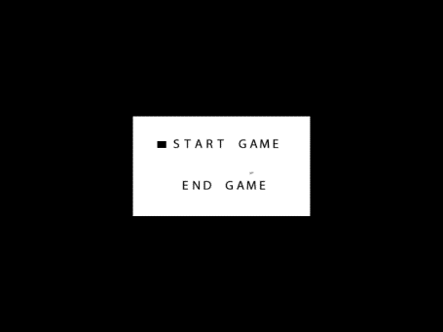 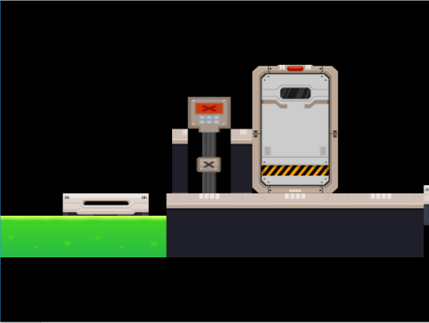

### Product functions

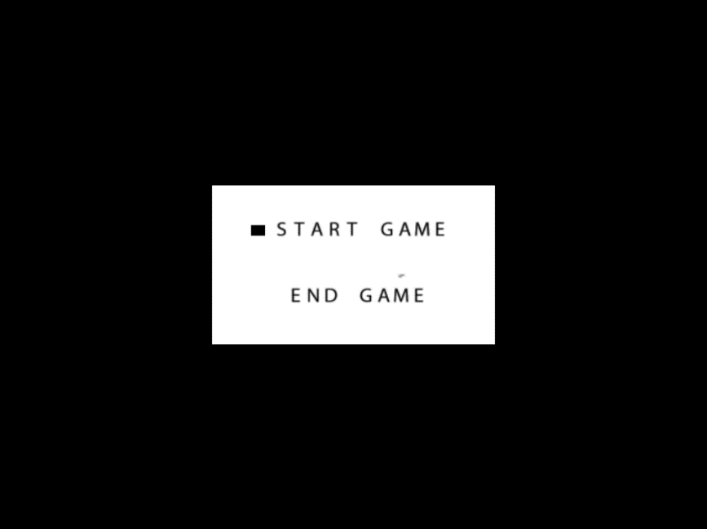

*The product will allow the user to manipulate a character around a 2D map. The movement of the character is restricted to left, right and jump. The user can activate pressure plates or press different buttons that can resolve puzzles, clear his way through the level or kill him.*

### User characteristics

*The user will be academics and students within the University of Portsmouth that are familiar with the use of computers and 3D graphical applications.*

### General constraints

**

### Assumptions & dependencies

*Define assumed factors that would cause the Requirements to change should the assumption be incorrect.*

*The requirements will be changed if some features take too much time to implement and their priority level is not high. In this case, alternative solutions will be considered and researched and the rest of the design will be adapted.*

## Specific Requirements

### Hardware Requirements

No other special input or output devices are going to be used outside of the keyboard, mouse and computer monitor.

### Software Requirements



### Interface Requirements



**Menu screen format:**



Use Up and Down arrows to navigate through menu and press the space-bar to select.

**Key mappings:**



**Storyboards and main gameplay mechanics:**

**M1-Moving platforms**

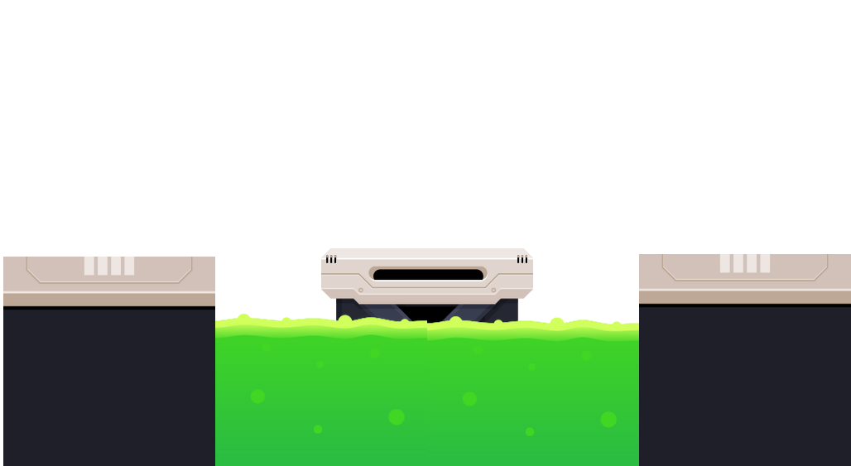

**M2-**

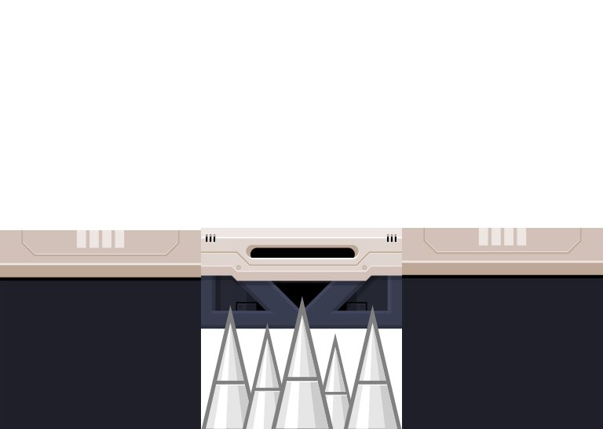

**M3-Spikes**

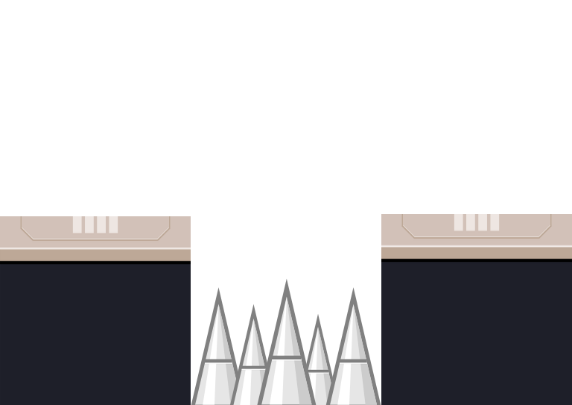

**M4- Moving spikes wheel**

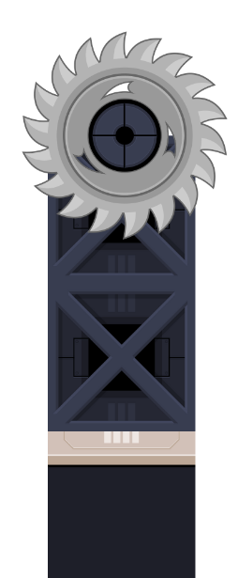

**M5-Teleportation**

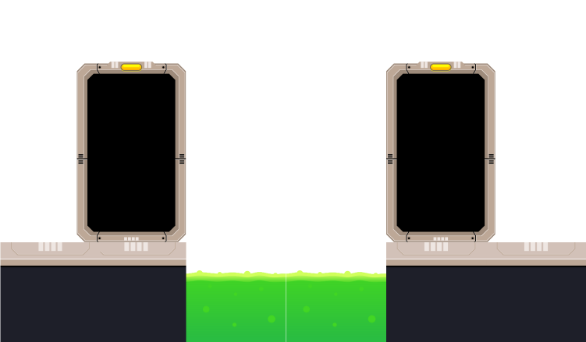

**M6-Open/Close Doors**

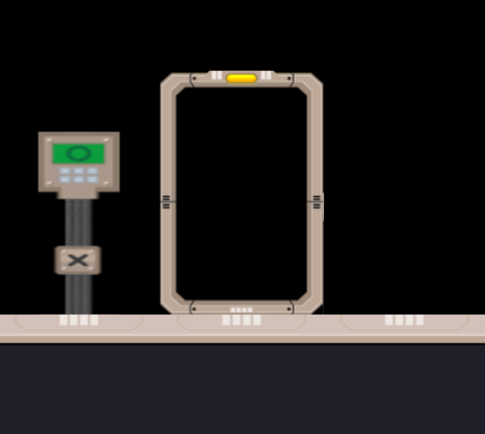 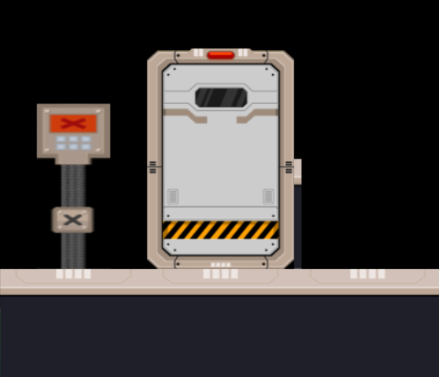



### Functional Requirements



The mouse input is not mandatory because the user can interact with the artefact by using the keyboard.

The pause menu is not mandatory because the level length does not require one and there is going to be just one level.

### Performance requirements



### Reliability requirements

*R1 - Mean time between failures will be 24 hours of game-play.*

### Design constraints

*The target hardware system will be a Pentium 4.*

*The memory available will be 512Mb of main memory.*

*The size of the final product is restricted to the size of the CD-ROM format (under 700Mb).*

*The graphics hardware required will be an NVidia GeForce 4.*

*The computer system will have the DirectX 10 runtime installed.*

# Software Design Description

## Design overview

*This section details the high-level look at the program and is used as a road-map to further define the component detail in the following sections.*

Game

Game Event Handler

End Game

Start Game

Mine Menu

Is Dead

Check player status

Is Alive

No

Level finished?

Yes

*Figure 3.1.1 – Software Structure Chart*

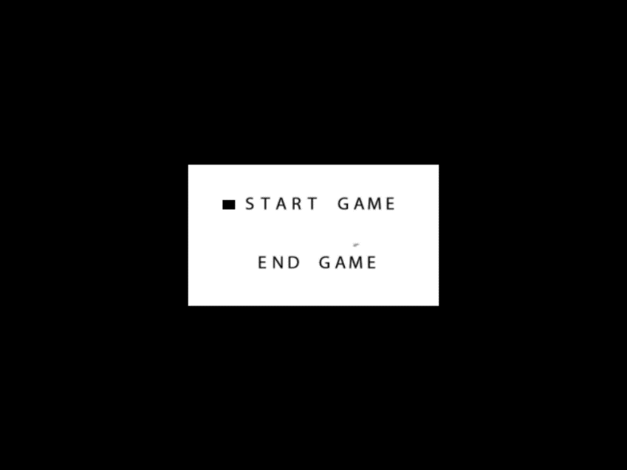

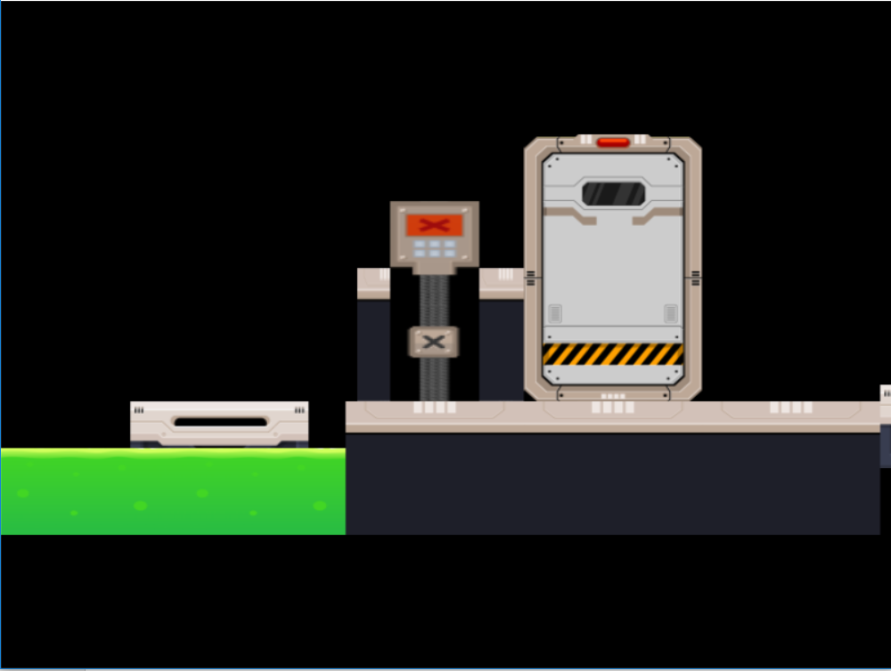

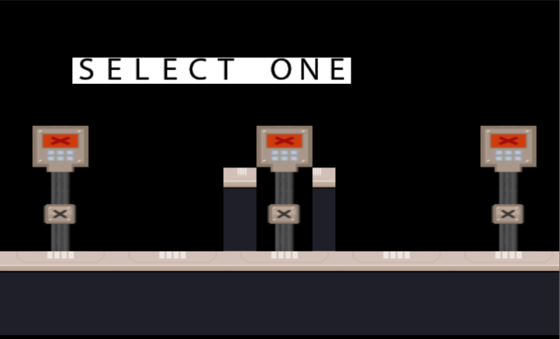

## Detailed design description

*This section provides a detailed design of components defined in the Design Overview above. This could be further defining each module defined in a structure chart for example.*

**

***D1-Game Event Handler***

*Description: This module will handle the events of the game: load menu, load game, end game and events that occur in the game.*

*Pseudo Code:*

*Begin*

*Receive Key Input*

*Update Graphics*

*Load Menu*

*If “Start Game” selected*

*If level is not loaded*

*Load Level*

*Check Player Status*

*If “Esc” key is pressed or Player is dead*

*Load Menu*

*If End Game selected*

*Exit Game*

*End*

***D2 – Player State***

*Description: This module checks if player is alive or not and his behavior in the game*

*Pseudo code:*

*Begin*

*IF Player is Alive*

*If “Esc” key pressed*

*Load mine menu*

*If Right Arrow is pressed*

*Move to right*

*If Left Arrow is pressed*

*Move to left*

*If player distance to button is in the defined range (//any button present in the game) and key “F” is pressed*

*Activate button/ Activate trap*

*//general cases*

*If player distance to spikes or wheelSpikes is in defined range*

*Player state=dead;*

*Return to mine menu*

*Else keep playing*

*End*

***D3- Collision Detection***

*Description: This module calculates the distance between two objects and returns that value*

*Begin*

*Use the Pythagorean theorem to calculate the distance*

*Return result*

*End*

***D4 – Moving Platforms***

*Description: This module describes the behavior of a platform that it is moving from point A to point B*

*Pseudo code:*

*Begin*

*Select start and end position*

*If obj.xAxis is equal to start position and the end point wasn’t reached*

*Increase obj.xAxis*

*If the object has reached the end position*

*end position=true*

*start position=false*

*If obj.xAxis is equal to end position and the start point wasn’t reached*

*Decrease obj.xAxis*

*If the object has reached the start position*

*end position=false*

*start position=true*

*End*

***D5 – Teleportation***

*Description: This module will make possible the movement of the player along the level. The player can use doors for teleportation from one position to another.*

*Begin*

*If door is open and player is in range*

*If ‘F’ button is pressed*

*Teleport player*

*End*

***D6 –Interact with buttons***

*Description: This module allows the player to interact with buttons that are present in the level. For example these can be used to open/close doors or activate traps*

*Begin*

*If player is in range and ‘F’ button is pressed*

*If button is not activated*

*Activate button*

*If button is active*

*Update Door Texture/Activate spikes*

*Update button texture*

*End*

***D7 – Menu States***

*Description: This module describes the menu states*

*Begin*

*If Up Key pressed*

*Update Graphics*

*result=1 (start game selected)*

*If DownKey pressed*

*Update Graphics*

*result=0 (end game selected)*

*return result*

*End*

***D8-Object Setup***

*Description: This module describes how objects are set in the game*

*Begin*

*Select texture*

*Select Vertex Type/Select String (If drawing text)*

*Set Texture*

*Set buffers, device and device context*

*Load Shader*

*Load the object*

*End*

***D9-Draw Object/Text on screen***

*Description: This module describes how objects are drawn in the game  
Begin:*

*Object Setup*

*Object Update*

*Apply transformations to object*

*Update Camera*

*Object Render*

*End*

***D10-Key Input***

*Description: This module describes how key inputs are defined  
Begin:*

*If keyDown message*

*Switch()*

*Case ‘key’: objectKey=true*

*Else*

*If keyUp message*

*Switch()*

*Case ‘key’:objectKey=false*

*End*

***D11-Door/Button Animation***

*Description: This button describes how buttons and doors are animated.  
Begin:*

*If button is activated*

*If door is close*

*Button is set to off*

*Change button texture*

*Door is open*

*Update Door Texture*

*ELSE*

*If door is open*

*Button is set to off*

*Change button texture*

*Door is closed*

*Update Door Texture*

*End*

***D12-Spikes Trap (activate by pressure plate)***

*Description: Spikes activated by stepping on a pressure plate  
Begin:*

*If (Collision detection between player and pressure plate)*

*Pressure plate is active*

*Change pressure plate position*

*If pressure plate is active*

*If spikes position >0*

*Spikes are falling*

*End*

***D13-Spikes Trap (activate by button)***

*Description: Spikes activated by stepping on a pressure plate  
Begin:*

*If (Collision detection between player and button)*

*If ‘F’ key is pressed*

*Set button On*

*Update Texture*

*If Button is On*

*If spikes position >0*

*Spikes are falling*

*End*

## Requirements Mapping



# Project Plan

## Project organisation

### Life cycle model

*This section depicts the major phases or stages of the project. Many different project structures may exist given the major differences between, for example, a large development, purchase of a package, enhancement of an existing system and so on.*

Stage

Reviews

Peer review

Prototyping

Peer Review

Design

Peer Review

Plan

Peer Review

Testing

Development

Peer Review

Post Project Review

### Project organisational structure

Student (Project Manager, Developer)

Student 2 (Peer-Reviewer)

Staff Member (Client, Peer-Reviewer)

## Managerial process

### Management objectives & priorities

*The progress of the project will be discussed informally in the workshop session for the course each week.*

*The aim is to create a product that meets the requirements and design and is delivered on time to a high-level of quality.*

*Peer reviews will be performed within the workshop environment to help review the progress of the project and reassess the projects risks.*

### Assumptions, dependencies & constraints

*The project will be completed by the due date of the final submission, which is the date of 30.03.2017.*

*The hours allocated to implement the project is 5 hours per week totaling 30 hours for the project.*

### Risk management

|  |  |  |  |
| --- | --- | --- | --- |
| Event or Risk | Probability | Severity | Preventative steps |
| *Development project late* | *Medium* | *High* | *Create a design document. Divide task into small parts.*  *Follow the plan. Priorities tasks.* |
| Break code or lose project | High | High | Use source control. |

### Monitoring & controlling mechanisms

*This is an individual project with the use of peer review techniques with fellow students as well as staff during workshop times to review project progress according to the timeline detailed in the document.*

### Staffing plan

*The project is an Individual approach with peer reviews performed by one other student and one other staff member.*

## Quality Planning

***Dealing with problems:***

***Commenting Standards***

*Comments will be done at the start of each file using the following model:*



In addition, comments will be added inside the code where it is required.

***Naming scheme:***



***Code formatting:***



## Work packages, schedule & budget

### Schedule



**Detailed development stage schedule:**

**

**

**

# Test Plan and Results

## Test Items

*This section details the test cases for the product along with the test result. This document will be revised in version for each time the set of test cases is carried out.*

|  |  |  |  |  |
| --- | --- | --- | --- | --- |
| Requirement | Design | Test | Test Case | Status |
| *R1* | *D8* | *T1* | *Load multiple objects* | *Failed 13/02/2017* |
| *R2* | *D9* | *T2* | *Draw multiple objects* | *Failed*  *13/02/2017* |
| *R3* | *D8* | *T3* | *Load multiple objects* | *Passed*  *19/02/2017* |
| *R4* | *D9* | *T4* | *Draw multiple objects* | *Passed*  *19/02/2017* |
| *R5* | *D9* | *T5* | *Orthographic Camera* | *Failed*  *20/02/2017* |
| *R6* | *D9* | *T6* | *Orthographic Camera* | *Passed 05/03/2017* |
| *R7* | *D3* | *T7* | *Collision Detection* | *Passed*  *05/03/2017* |
| *R8* | *D10* | *T8* | *Key Input* | *Failed*  *08/03/2017* |
| *R9* | *D7* | *T9* | *Mine Menu* | *Failed*  *08/03/2017* |
| *R10* | *D4* | *T10* | *Platform AI* | *Failed 13/03/2017* |
| *R11* | *D12,D13* | *T11* | *Spikes traps* | *Passed*  *13/03/2017* |
| *R12* | *D5* | *T12* | *Player teleportation* | *Passed*  *13/03/*  *2017* |
| *R13* | *D6* | *T13* | *Interact with buttons* | *Passed*  *15/03/2017* |
| *R14* | *D7* | *T14* | *Pause Menu* | *Failed*  *15/03/2017* |
| *R15* | *D4* | *T15* | *Platform AI* | *Passed*  *15/03/2017* |
| *R16* | *D11* | *T16* | *Door/Button Animation* | *Passed*  *16/03/2017* |
| *R17* | *D10* | *T17* | *Key Input* | *Passed 16/03/2017* |
| *R18* | *D1* | *T18* | *Game Event Handler* | *Failed*  *23/03/2017* |
| *R19* | *D2* | *T19* | *Player State* | *Passed*  *23/03/2017* |

## Test Report Results

***Date:*** *13/02/2017*

***Tested:*** *T1, T2*

***Issues Encountered:*** *Couldn’t load multiple objects and draw them on the screen.*

***Date:*** *19/02/2017*

***Tested:*** *T3, T4*

***Issues Encountered:*** *-*

***Description:*** *Multiple objects can be now loaded and drawn*

***Date:*** *20/02/2017*

***Tested:*** *T5*

***Issues Encountered:*** *The camera is set to Perspective View instead of Orthographic. When the camera is set to orthographic nothing is drawn on the screen. The depth buffer is not working.*

***Date:*** *05/03/2017*

***Tested:*** *T6*

***Issues Encountered:*** *-*

***Description:*** *Camera orientation was successfully switched from Perspective to Orthographic and the position is updated when needed.*

***Date:*** *05/03/2017*

***Tested:*** *T7*

***Issues Encountered:*** *Collision detection is working.*

***Date:*** *08/03/2017*

***Tested:*** *T8, T9*

***Issues Encountered:*** *The mine menu is not responding properly to the key input.*

***Date:*** *13/03/2017*

***Tested:*** *T10*

***Issues Encountered:*** *Platforms is not moving between two set points. The platform stops at the end point.*

***Date:*** *13/03/2017*

***Tested:*** *T11*

***Issues Encountered:-***

***Description:*** Spikes traps are working

***Date:*** *13/03/2017*

***Tested:*** *T12*

***Issues Encountered:*** *Player teleportation is working.*

***Date:*** *15/03/2017*

***Tested:*** *T13*

***Issues Encountered:***

***Description:*** *In game buttons are working but are not animated.*

***Date: 15.03.2017***

***Tested:*** *T14*

*Issues Encountered: The Z ordering is not working when the pause menu is loaded.*

***Date:*** *16/03/2017*

***Tested:*** *T13*

***Issues Encountered:***

***Description:*** *Open/Closed doors animation is working when activating buttons.*

***Date:*** *16/03/2017*

***Tested:*** *T13*

***Issues Encountered:***

***Description:*** *Key Input is working.*

***Date: 23/03/2017***

***Tested:*** *T16, T17*

***Issues Encountered:*** *The level does not reset when the player dies or the user decides to go to the mine menu. Player alive/dead states are working.*

## Features not to be tested

D14-Physics Simulation

The physics simulations are not going to be implemented or tested because of the amount of time that it requires to be implemented.

**Overall testing results:**

**D1-Game Event Handler**

The Game Event Handler is partially working. The pause menu state is not implemented. The level is not restarting when the player dies or exits to mine menu.

**D2-Player State**

Dead/Alive states are working

**D3-Collision Detection**

Collision Detection is partially working. There are no physics simulations implemented. It detects only if a certain object is in range or not.

**D4-Moving Platforms**

The platforms are moving form a defined point A to a defined point B. Physics simulations are not implemented.

**D5-Teleportation**

Teleportation mechanic is fully working.

**D6- Interact with button**

Working

**D7-Menu States**

Working

Working

**D8-Object Setup**

Working

**D9-Object Draw/Text Draw**

Working

**D10-Keyboard Input**

Working

**D11-Door/Button Animation**

Working

**D12-Spikes Trap (activated by pressure plate)**

Working

**D13-Spikes Trap(activated by button)**

Working

**D14-Calculate physics forces**

2D Physics simulations are not implemented.

# Post Project Review

*The post-project review is an information gathering and evaluation exercise to determine what worked well and what did not during the personal project. From this recommendations are drawn about how projects can be run more effectively in the future.*

## Effective Project Procedures

***Multiple sources***

For this artefact, I used multiple books as reference sources. Also, I tried to use different websites but I abandoned this approach because the information provided wasn’t that helpful and sometimes too ambiguous. Furthermore, books proved to be the best choice for someone that haven’t worked with DirectX because before most of the aspects were well explained.

Even if I had problems binding code from two different books I managed to get more features working. Also, I believe that helped me to develop my skills because I needed to have a good understanding of code in order to be able to get it working. Furthermore, I was able to compare code and I did find multiple ways of implementing it.

***Talking with other people***

*When I had problems with my code I used to search the problem on the internet but this didn’t work all the time because most of the sources were not reliable. I tried to talk with other people that are doing this course and this proved to be a very good decision because some of them encountered similar problems as mine.*

***Prototyping Stage***

*I spent a lot of time on the prototyping stage and even if from my point of view, I started working on the actual project quite late (mid-February) but by doing this I had a better understanding of the code when I started working on the actual project.*

## Ineffective Project Procedures

*Detail the procedures that were ineffective during the project production.*

***Version Control***

*For this project, I didn’t use the source control even if we were told to do so. What I did instead was making backup saves of my code and uploading them on Google Drive. This proved to be a bad decision because I ended up with lots of backup saves, most of them not working and I couldn’t keep track of errors. It happened that I broke the project and I had to start everything again from scratch and this lead to delays.*

***Planning***

*We were supposed to create a well-documented plan before starting working on the project. This didn’t happen, and I was planning my work from week to week. This approach lead to delays and I had to abandon some features such as Physics Simulation.*

***Documentation:***

The documentation was supposed to be done while working on the game but I did the most of the documentation in March. Doing documentation while working on the artefact would have helped me to organize my work better and keep track of progress or problems that I encountered.

***Code organization:***

The code was highly influenced by the lack of documentation and planning in the early stages. I think that my code could be improved by adding more functions because I some parts of it are repetitive. Also, I think that I haven’t done a good work with classes because I ended with some classes that have lots of variables while others just two or three and some of them are quite ambiguous because their function differs from object to object. So a plan of the code structure in the early stages would have helped.

## Estimation Accuracy

*Detail the difference between the project estimates and the real times and dates of delivery.*

*My estimation was that I can finish the project in 6 weeks but I was wrong. The physics simulation mechanic proved to be complicated and I abandoned it because it required too much time. Also, as I said before, I lost a lot of time because I didn’t use the source control and I had to rewrite multiple times some parts of my code.*

## Recommendations

*List recommendations for how future projects could be done more effectively.*

*For the future projects, I will try to spend more time on planning and writing the documentation because so I can save time and be more organized. I think organization can have a big impact on code quality and on its performance.*

*Also, I should use the source control in order to avoid losing my project or breaking it and losing time trying to fix it. Making backup saves is not really the most professional way of taking care of your code and it also has its risks. Working with the source control is the most professional way of backing up your code and this is how it is done in the industry.*